# 

# **We Serve**

   
 

**Documentation**

**User Manual**

**Table of Contents**

1. Introduction……………………………………………………………………………..…3

1.1 Scope and Purpose…………………………………………………………………….3

1.2 Process Overview……………………………………………………………………...3

1. Getting Started…………………………………………………………………………….4

2.1 Setup Considerations………………………………………………………………….5

2.2 The About Page………………………………………………………………………..5

2.3 Exiting the System…………………………………………………………………….6

1. Navigating on the WeServe application…………………………………………………...7

3.1 Vendor………………………………………………………………………………....7

3.2 Customer……………………………………………………………………………....7

1. Registering on the application…………………………………………………………….7

4.1 Register as a Vendor…………………………………………………………………...8

4.2 Register as a Customer……………………………………………………………….11

1. Customer Searching for Vendor…………………………………………………………13
2. Edit customer details……………………………………………………………………..15
3. Edit vendor profile…………………………………………………………………….....16
4. The Vendor providing the services…………………………………………………....…17
5. The Customer accessing the services………………………………………………….....18
6. Queries Form on the application………………………………………………………....19

Appendix A: Record of Changes………………………………………………………...21

Appendix B: Glossary…………………………………………………………………....22

**1 Introduction**

“WeServe” is an application that provides small-scale businesses a platform to sell their services and products to customers. In essence, “WeServe” is an e-commerce site similar to Etsy or Amazon but is capable of providing much more than just products. “WeServe” will act as the middleman, allowing customers to purchase local products through vendors on “WeServe”. WeServe also verifies the license of vendors before registering them on our application. This documentation is going to guide the users through the various processes that take place in the WeServe application and how to go through the tasks.

**1.1 Scope and Purpose**

The scope of our project is to develop an application which provides a single platform to buy and sell religious / cultural things, fresh fruits or vegetables, as well as provide services such as repairing home appliances, plumbing and carpeting.

The purpose of our platform will help such skilled people to expand their businesses under their brand name and also customers will have them at a reasonable cost.

**1.2 Process Overview**

The We Serve application will register the users and allow verified users to log in. In our application the users can choose from a list of vendors and contact them. Moreover, vendors can describe their products and customers can give ratings based on their experience. The customers won’t be able to see vendors unless they are signed in into the application.There will be an admin who will manage the vendors and customers. Our application has omitted the insurance system that is the replacement of a broken product will be handled by the vendor themselves and the help centre services are excluded.

**2 Getting Started**

The application here is a web application which is hosted to provide the users with the appropriate functionalities and rights according to the role of the user. The user is able to navigate through the web application in accordance to if the user is the admin, customer or a vendor. Examples include hand made tools, fresh fruits and vegetables from farms, religious/ethnic items and services such as carpentry, or stone work. The application is designed to broker a middle man between a small business owner and their clients. The application's purpose is to be an alternative to services such as Amazon, or Alibaba; supporting local businesses instead of corporations. The concept is to provide better quality products at cheaper prices. For the existing solution, there is no such application in the market which provides all of the functionalities that we are going to provide.



Figure 1: The WeServe application hosted on the web browser.

**2.1 Setup Considerations**

In order for the the set up of the web application, the following considerations must be taken into consideration before starting:

1. A browser requirement for using Internet Explorer, version 6.0 or higher.
2. 800x600 resolution or higher is required for accessing the web application on the browser.
3. Must standardize an API for adding web applications to the homescreen.

**2.2 The About Page**

The users can navigate to the “About Us” page to find out about information about the application and its objective and purpose. This page details what the application entails on the perspective of what different users can do.

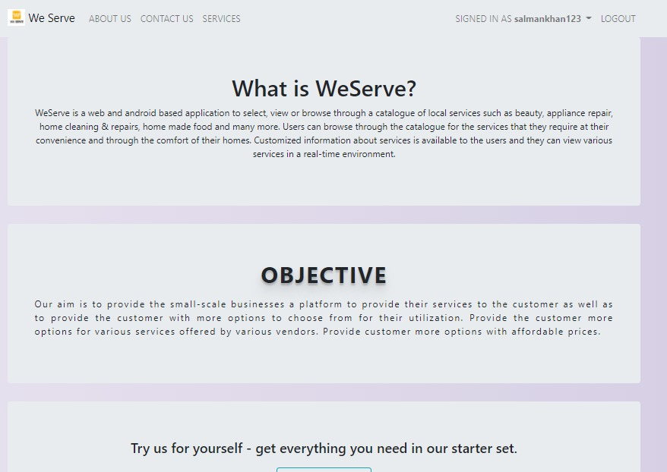

Figure 3: The About Page of the WeServe application.

**2.3 Exiting the System**

Since this is a web application, the process of exiting the application is rather simple. If a user wants to exit the application, the user will need to close the browser which is hosting the application and thus, the user will have exited the web application.

User is able to log out of the system. Once the user logs out of the system, we are greeted with the home page of the application.

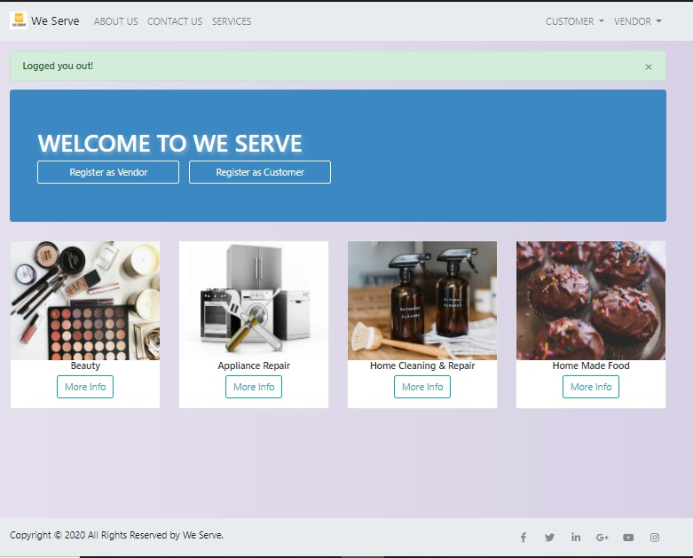

Figure 4: The Home Page after the user logs out of the WeServe application.

**3 Navigating on the WeServe Application**

Since the WeServe application is hosted, it is feasible to navigate through the website through the use of a web browser.

**3.1 Vendor**

This User Role is a consolidated version of both Service Provider and Vendor. This was done because they both share very similar stories and attributes. The Vendor User Role will primarily deal with the vendors who wish to sell their skills and products to the consumer. To sell on the system, Vendors will need to leave their contact info on their profiles. From there, consumers will contact them and negotiate with them. The WeServe Application will only serve as a middleman between the vendors and consumers.

When the user navigates to the vendor page

**3.2 Customer**

This is the most integral user of the application. The most who is going to use the app is the consumer, who is looking for several products/services in the application. Most of the users will be good with mobiles and computers as they will be using such platforms to get services. They will be comfortable with the product we develop with their primary goal being getting the service without any bugs or inconvenience in one way or another.

**4 Registering on the application**

The users who are not admin as able to register themselves as a customer or vendor on the application as discussed below. Currently, services are not secure but when customers use our application, their safety is considered as we will be verifying their license before making their services available on our application. To overcome the mentioned problems there is no application, as well as there is no such application which verifies the license of the person before booking them for repair.

**4.1 Registering as a Vendor**

When the user navigates to this page, the user will be required to fill all the fields present in the page in order for the user to register himself on the application as a vendor. The fields which need to be filled include:

1. Profile Picture
2. First Name
3. Last Name
4. Creating a username for the web application
5. Email
6. Creating a password for the account creation
7. Full Address along with Postal Code
8. Contact Number
9. The field the user wants to register as a vendor

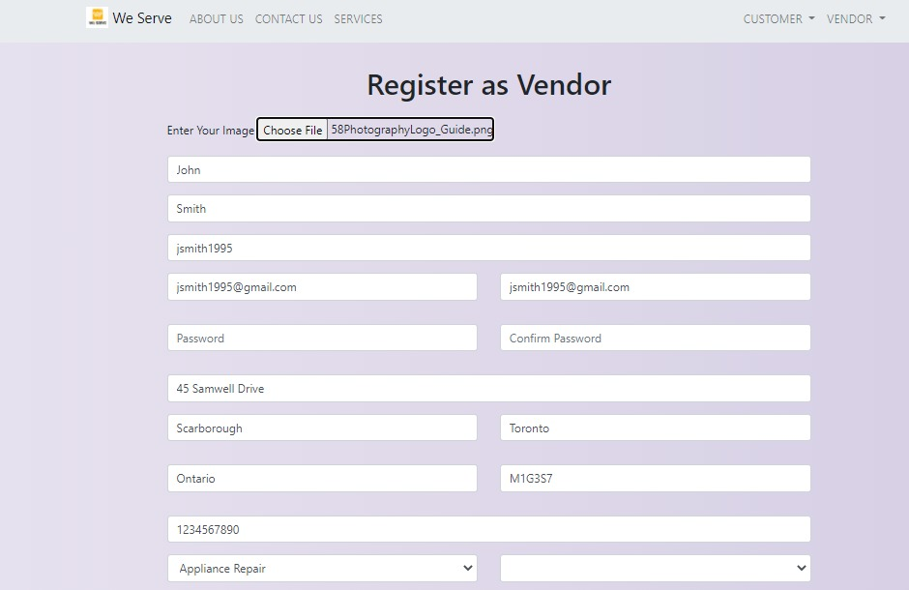

Figure 4: Registering as a vendor on the WeServe application.

When you click on the system, the admin will be verifying the vendor first and then only can the vendor proceed with providing the services.

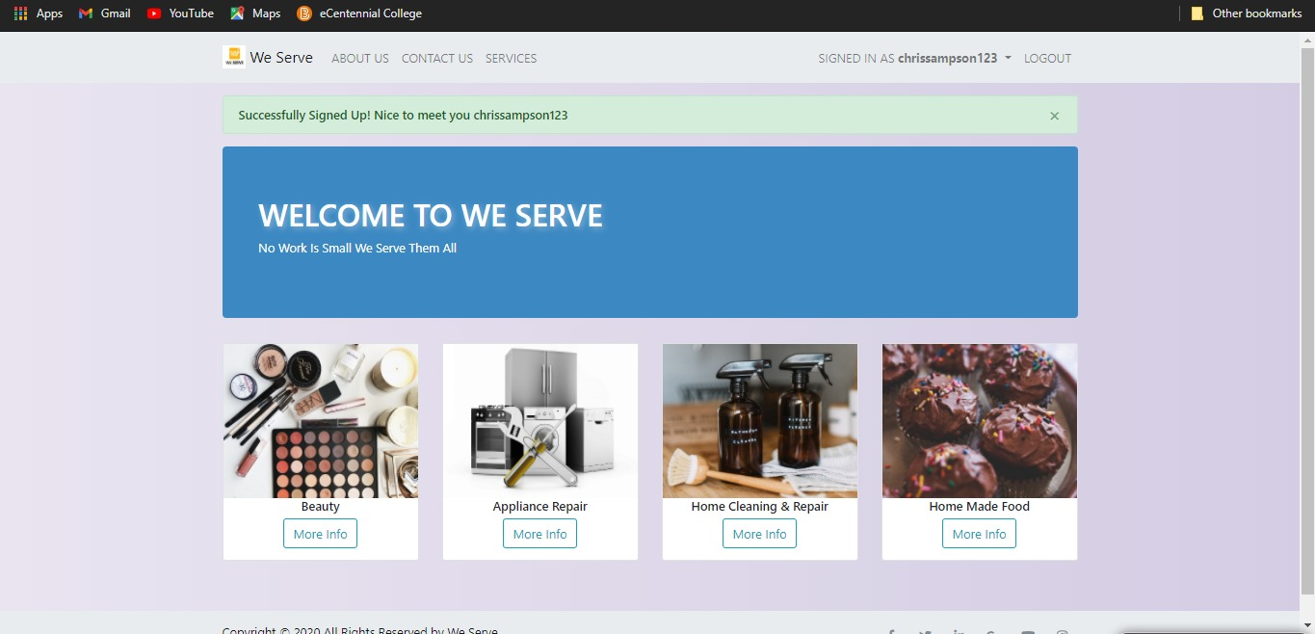

Figure 4: Registering as a vendor on the WeServe application.

There are a little more security restrictions allowed for registering as a vendor and it all needs verifications in the system in order for the registering to be complete. The admin has all the rights and the admin will be needing to manage all the vendors and customers on the application.

After the user has registered as a vendor, he can view his profile on the web page and perform all the following tasks on the profile:

1. The vendor can delete his account from the system from the profile page.
2. The vendor can edit his profile.
3. The vendor can see his reviews.

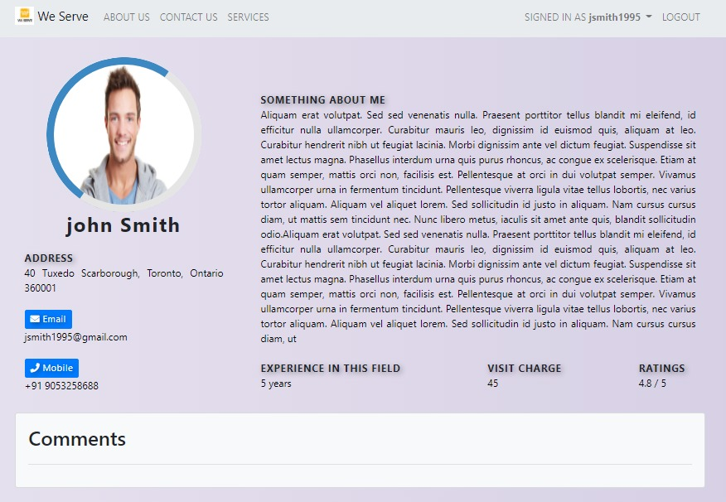

Figure 5: The profile page of the vendor on the WeServe application.

**4.2 Registering as a Customer**

When the user navigates to this page, the user will be required to fill all the fields present in the page in order for the user to register himself on the application as a customer. The fields which need to be filled include:

1. First Name
2. Last Name
3. Creating a username for the web application
4. Email
5. Creating a password for the account creation

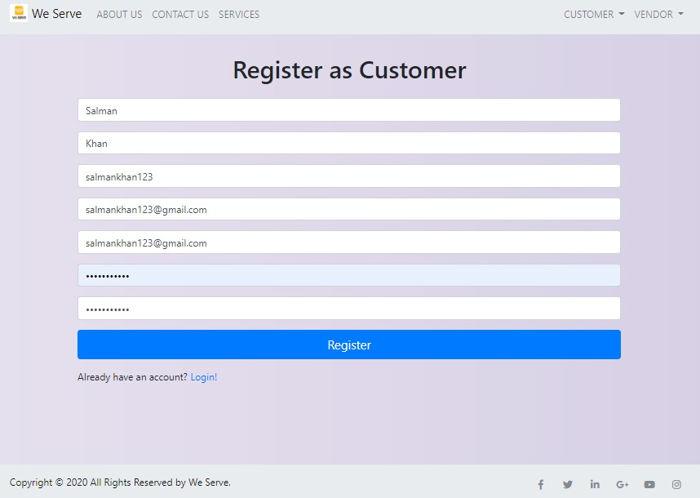

Figure 6: Registering as a customer on the WeServe application.

After the user has registered as a customer, he can view his profile on the web page and perform all the following tasks on the profile:

1. The customer can request a service via the application.
2. The customer can search for a specific service.
3. The customer can edit his profile in the application.
4. The customer can view the vendor details for the services.
5. The customer can delete his account from the system via the profile page.

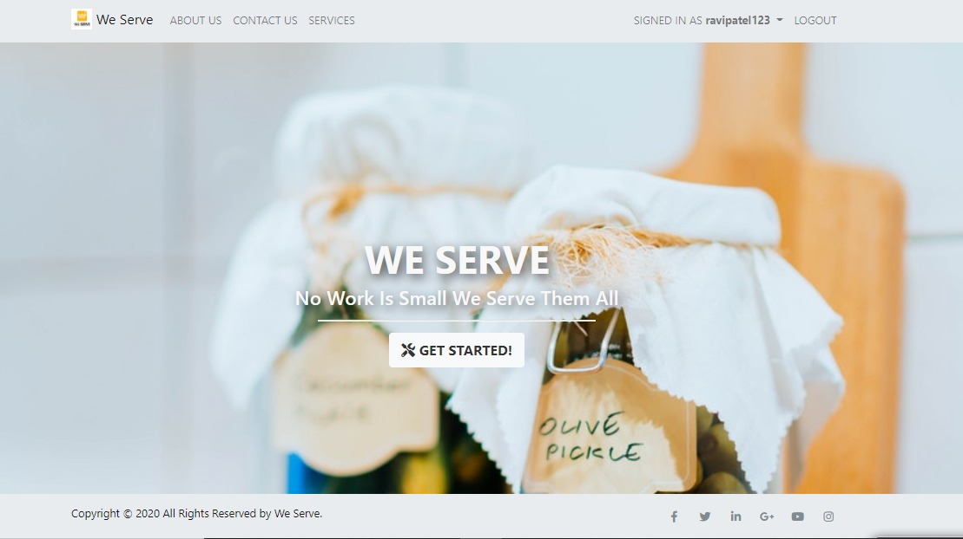

Figure 7: The home page of the customer signed in on the WeServe application.

**5 Customer Searching for Vendor**

If a customer is looking for salon services at home, then the customer can look up for those services at the web application.

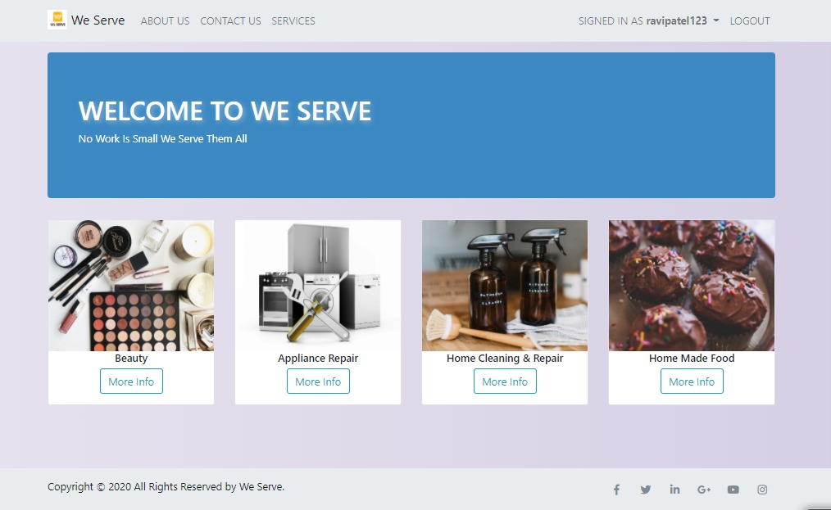

Figure 7: The home page of the customer signed in on the WeServe application.

When the customer chooses the beauty products category, then the customer is shown with the following screen where he can choose further services.

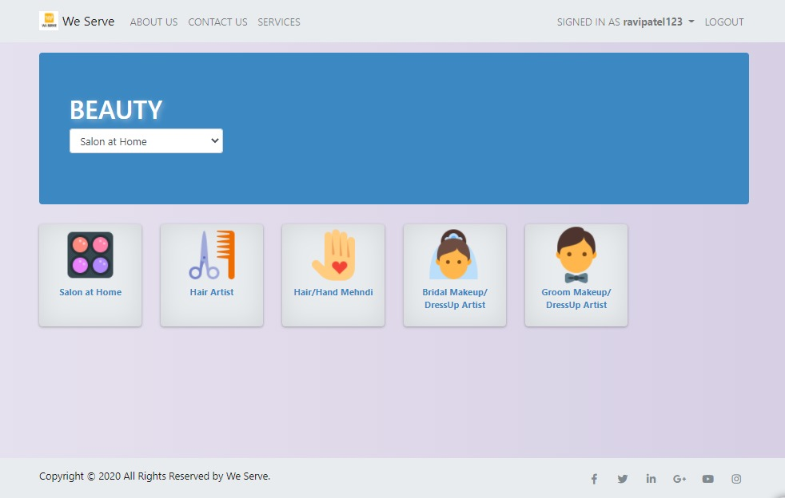

Figure 7: The home page of the customer signed in on the WeServe application.

Then, the customer will be shown the vendors who are available to provide the selected services. The customer can click on the vendors for more details by also checking the ratings.

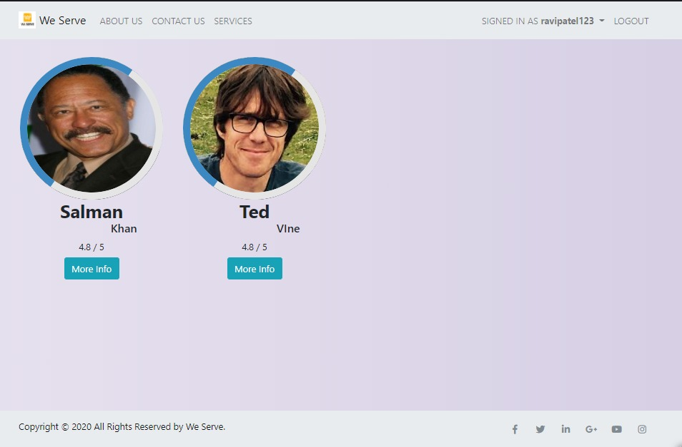

Figure 7: The home page of the customer signed in on the WeServe application.

The customer can post and check the reviews of the vendor inside the vendor’s profile. He can view all the details about the vendor and check the contact details to proceed with the services from the vendor. The vendor can be contacted via email or phone number.

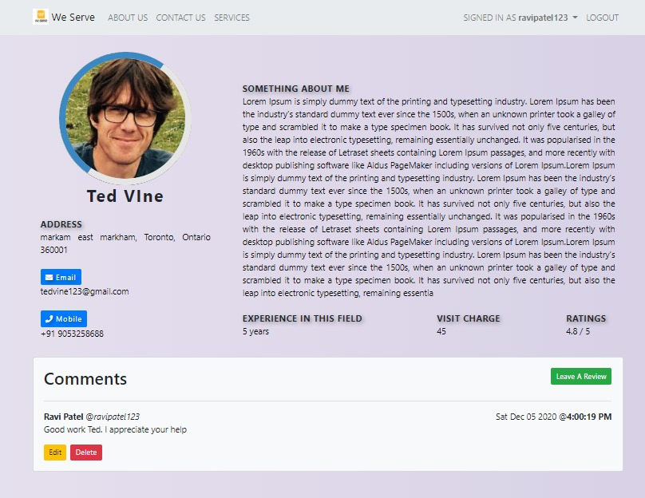

Figure 7: The home page of the customer signed in on the WeServe application.

**6 Edit customer details**

The customer can edit his profile by clicking on his name on top right as seen in the figure.

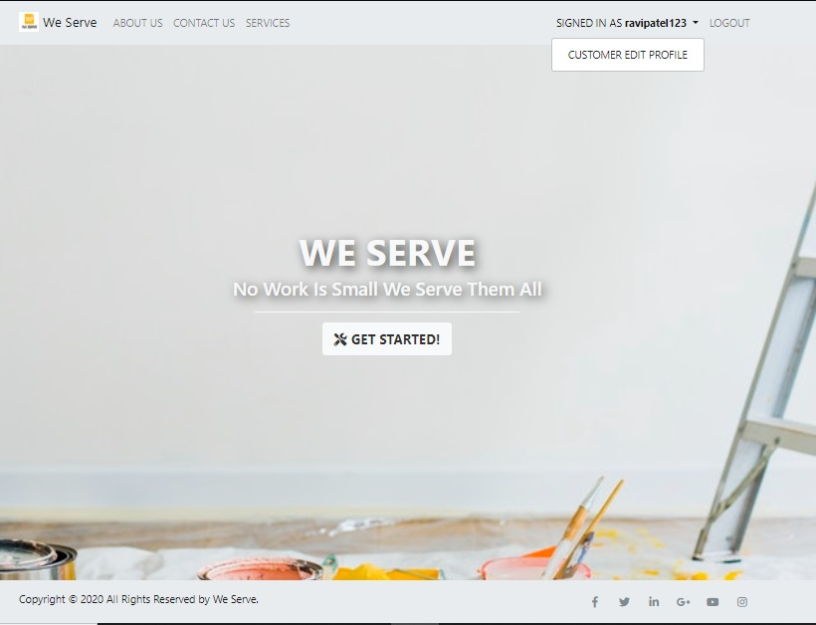

Figure 7: The home page of the customer signed in on the WeServe application.

The customer is directed to the editing page where he can edit his profile as shown below.

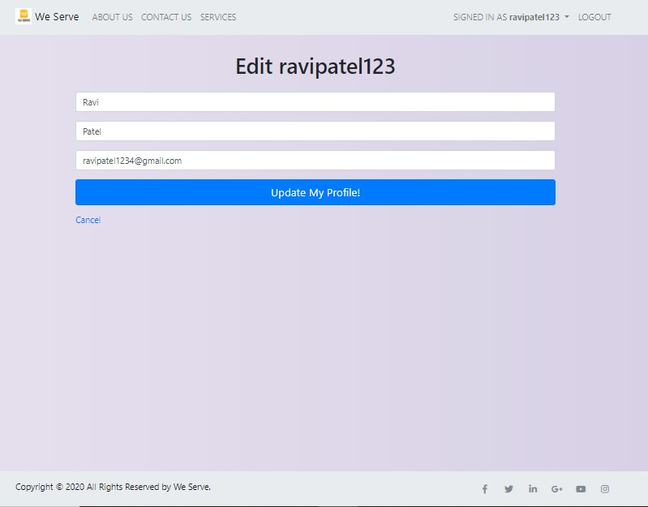

Figure 7: The home page of the customer signed in on the WeServe application.

**7 Edit vendor profile**

The vendor can edit his profile by clicking on his name on top right as seen in the figure.

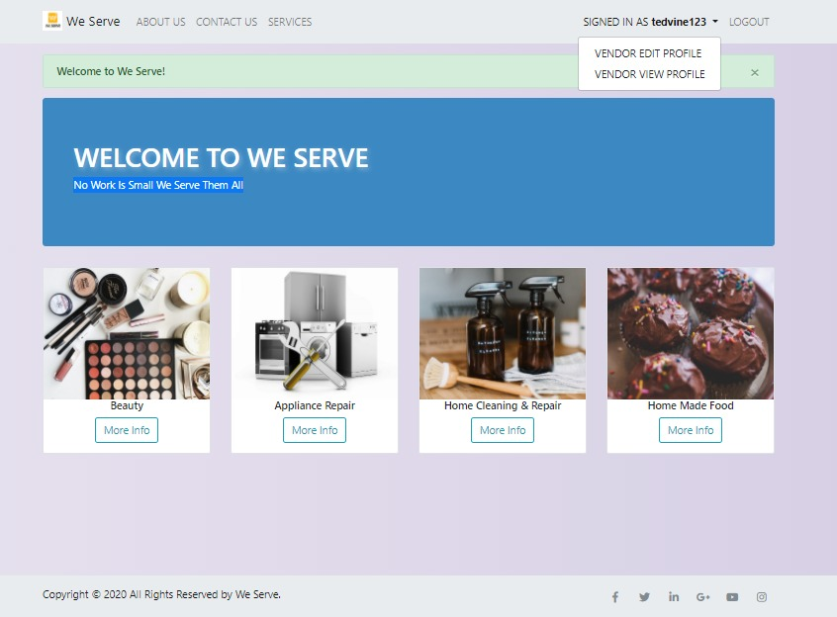

Figure 7: The home page of the customer signed in on the WeServe application.

The vendor can edit all his details as shown in the figure below.

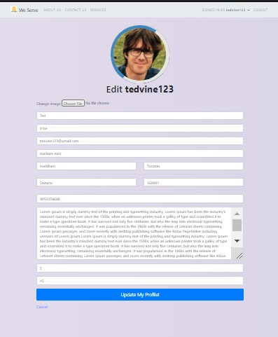

Figure 7: The home page of the customer signed in on the WeServe application.

**8 The Vendor providing the services**

Once the vendor has created his profile, he is going to wait for the customers to call him for services. A vendor can only register to provide one kind of service at a time.

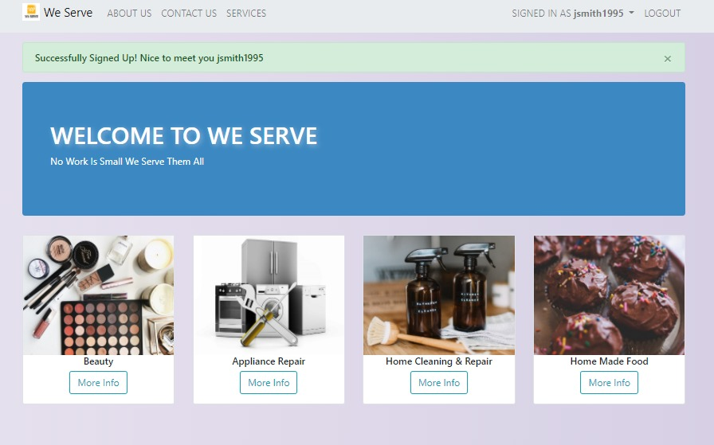

Figure 8: Services offered by the vendor of expertise Beauty on the WeServe application.

**9 The Customer accessing the services**

The customer registration process is shorter and after the registration, he can choose from the variety of services available to access. For example, in Figure 9, the customer is seeing the options for the beauty services. He can choose from the services which are listed as below in the dashboard. For this particular figure, we can see that he has access to five different kinds of services, namely, solon at home, hair artist, hair/hand mehndi, bridal makeup/dressup artist and groom makeup/dressup artist.

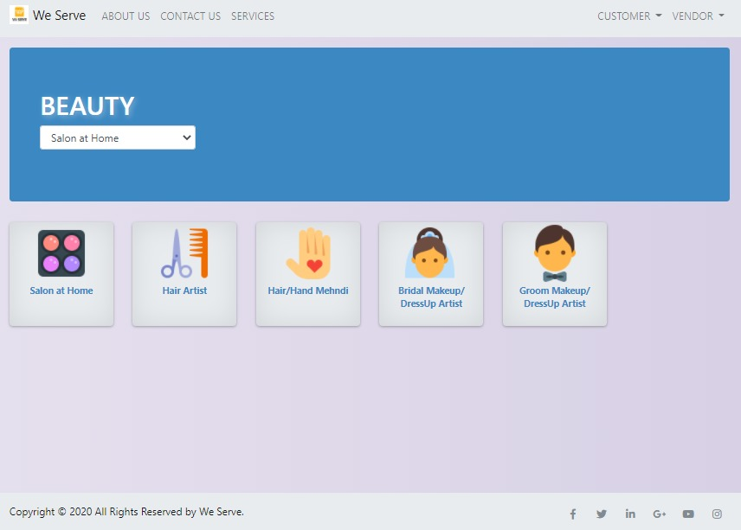

Figure 9: Services accessible to customer in expertise Beauty on the WeServe application.

**10 Queries Form on the application**

The users have access to the “Contact Us” page, where they are able to share any queries they have for the web application. In order to inquire for a particular thing, they users will need to provide the following details:

1. Full Name
2. Email
3. Contact Number
4. Subject of inquiry
5. The message that want to send

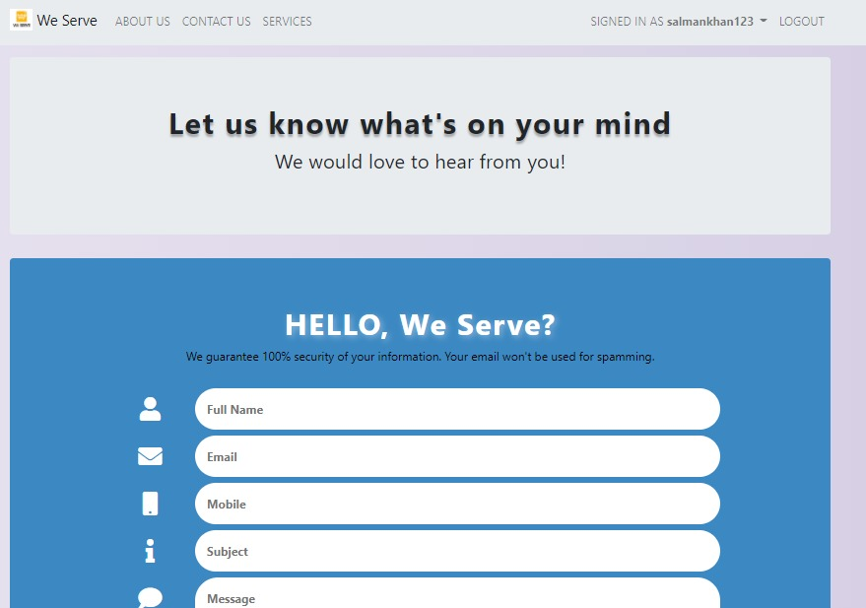

Figure 10: Contact Us page on the WeServe application.

**Appendix A: Record of Changes**

|  |  |  |  |
| --- | --- | --- | --- |
| **Version Number** | **Date** | **Author/ Owner** | **Description of Change** |
| 1.0 | November 19, 2020 | Bhargav Marsonia | Initial Draft |
| 1.1 | December 7, 2020 | Bhargav Marsonia | Final Draft |
|  |  |  |  |

**Appendix B: Glossary**

|  |  |
| --- | --- |
| **Term** | **Definition** |
| Admin | An Administrator provides office support to either an individual or team and is vital for the smooth-running of a business. |
| Vendor | In a supply chain, a vendor, or a seller, is an enterprise that contributes goods or services. Generally, a supply chain vendor manufactures inventory/stock items and sells them to the next link in the chain. |
| Customer | In sales, commerce and economics, a customer is the recipient of a good, service, product or an idea - obtained from a seller, vendor, or supplier via a financial transaction or exchange for money or some other valuable consideration. |